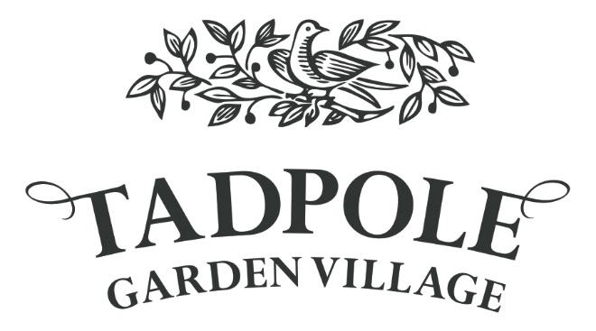

Response Form
Community Consultation
Wednesday 18th January 2016

Proposals for approximately 150 additional dwellings at Tadpole Garden Village.
We very much welcome your comments in relation to proposals discussed here today.
Your name and address will not be made public. However it helps us to understand who is interested in proposals at Tadpole Garden Village.
Your details
Name: ……………………………………………………………………………………………………………………….
Address (optional): ……………………………………………………………………………………………………
………………………………………………………………………………………………………………………………….
………………………………………………………………………………………………………………………………….
Email (optional): ……………………………………………………………………………………………………….
Please leave the response form in the box provided or send to Sarah Foster at Sf Planning Link by Friday 27th January 2017 either by e-mail, sarah@sfplanninglink.co.uk or post to:

Sarah Foster
SF Planning Link
Southsea Cottage
Days Lane
Kington Langley
Nr. Chippenham
Wiltshire
SN15 5PB

Questionnaire

- Do you live at Tadpole Garden Village?
Yes No
- Are you looking to live at Tadpole Garden Village?
Yes No
- Do you have children at Tadpole CE Primary Academy?
Yes No
Your Comments
Please use the space below to record any comments you may have relating to the proposals presented here today:

Under the Data Protection Act 1998 we will ensure the data you supply to us is processed with skill and care in accordance with the legislation and codes.
Your details will not be passed to any third party. We will not contact you for promotional purposes.

